Big Idea - Cloud Chime

I propose an interactive message unit which allows you to communicate through senses, movement, sound and light with friends and family one to another across the globe to keep in touch, to feel emotionally and socially connected in a playful way in this heavy technology driven lonely 21st century. Smart interfaces and physical buttons are not present for the sole purpose to reduce the technology appearance aspects of the product - the concept of invisible technology, break away from smart interface with sculptural and playful exterior and embedded technology “hidden” inside.
Make it easy access to all age groups and any technology knowledge background. The user's experiences therefore become the most important part in this product. Aim to tackle the issue of loneliness in this heavy tech-driven era with colourful, light hearted, less technology focused and more user focused product to achieve the ultimate goal of raise one's quality of life and well-being.

Appearance – Cloud Chime
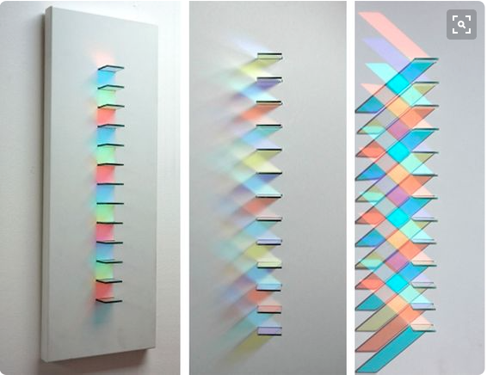
- The main factor is change by motion, colour, movement, sound and light

- The appearance of the product aim for the concept of being invisible, it appears invisible with the glass/transparent exterior when it's not being used, when interact with the product, light, movement and sound will make the product become “visible”

- LED laced wire as the structure of the 3D cloud shape exterior, glass exterior break up into small glass panels and metal pipe wind chime
attached below for “natural” sound effect Chris Wood, light artist

- Material - glass, wood and metal

Key Functions - invisible technology

- Kaleidoscope effect - The main interaction with cloud chime is the motion of touch sensor to turn on the LED wire and activate moving glass panels / indicate presence. Moving glass panels will create angels which reflect different LED lights to create different shades of colour

- Motor and LED light fit within Cloud Chime, the different angel of panels reflect moving LED light, make the panels and reflections appears to be moving.

- Wind chime controlled by moving motor which turns on by motion sensor, create crispy sound effect.

Cloud Chime looking at loneliness as the main issue, use a playful way to communicate with loved ones globally in a form of colour, sound, movement use the factor of change. As loneliness is a big issue, my product isn't aiming to change the world, but to break away the depressing and seems cold atmosphere with colour and sound, to find the time to interact with loved ones who are not around in a small way to remind them you are thinking of them, engage interaction within connect home globally to feel more emotional and socially connected.
For me personally, I find it difficult to speak to my family overseas even with smart devices which are designed to communicate with people instantly. I often find it losing its personally touch and often find myself with busy university schedule and personal errand on top of the time differences. Cloud chime can sit anywhere from a working desk top to the kitchen counter, interact with touch which seems a really easy effect in no time just by reaching out of hand, accompanied by the crispy sound and colourful movement, it is this small interaction and the factor of change that make you feel included and connected with loved ones. There are a lot of international students, busy working class away from home, all over the world, I believe they will benefit from this product like I would. Plus the old and much younger generation who can use it to communicate with loved ones away, it's simple touch activated sensor is easy to use to any age group and beautiful exterior will grab their attention.

If I had more time, I would like to have a go at my original wire structure and fitted with glass panel idea, which can take a bit of time and more code knowledge and with the possible help of 3D printer, this may be carry into future study module.
More polished exterior of the prototype need to be take into consideration for future project, this experienced prototype have solved all the issue besides one, the transport of the signal from one location to the other. In order to do this, I need to learn how to link two Arduino board in different locations together through wifi or bluetooth.
Some extra work can also help this product would be to conduct surveys and interview, this would be beneficial for getting feedback and see how it fits with real people in the real world.

As this week end also mark the end of creative technology module, I have gained some knowledge in basic understanding of Arduino and think creatively with technology in mind. I learnt new ways to interact with lectures and peers through platform like Slack and GitHub, I aim to carry those new skills and knowledge through my future studies.

